**Lab: Create New Public Certificate**

**Services Used: Certificate Manager**

1. Go to Certificate Manager Services in AWS Console.

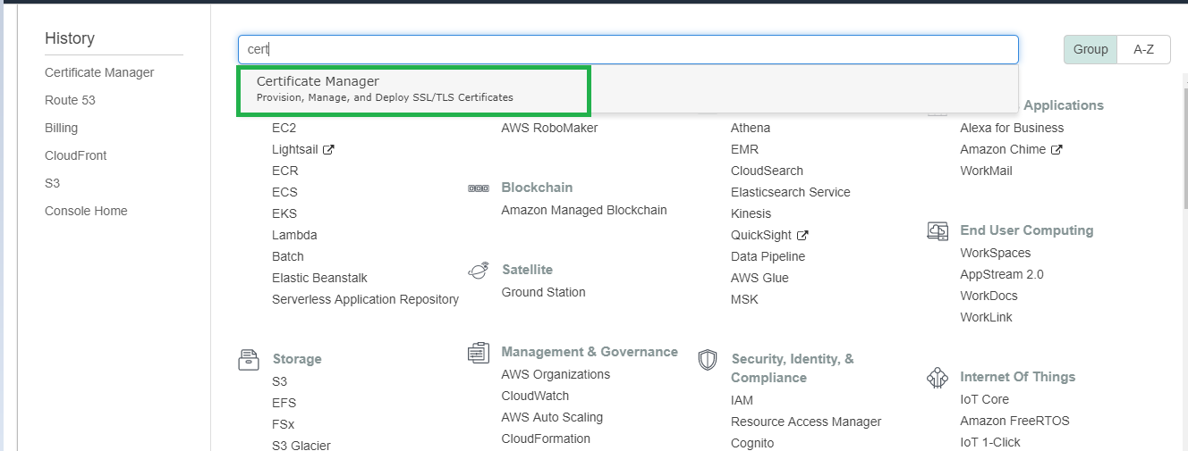

1. Under Certificate Manager select Request a certificate.

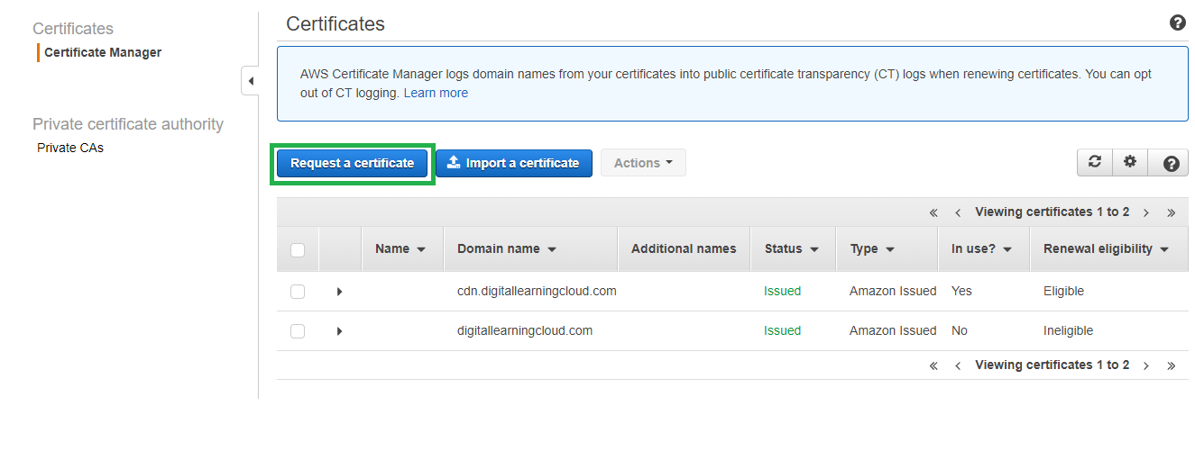

1. Select request a public certificate and click Request a certificate

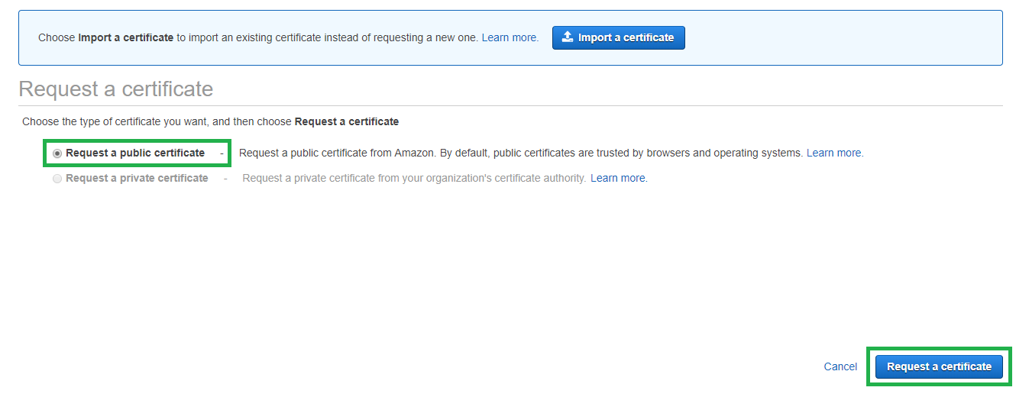

1. Provide the domain name for which you are requesting certificate. Add multiple name if required otherwise provide only required name and click next. In this example we are requesting new certificate for test.digitallearingcloud.com

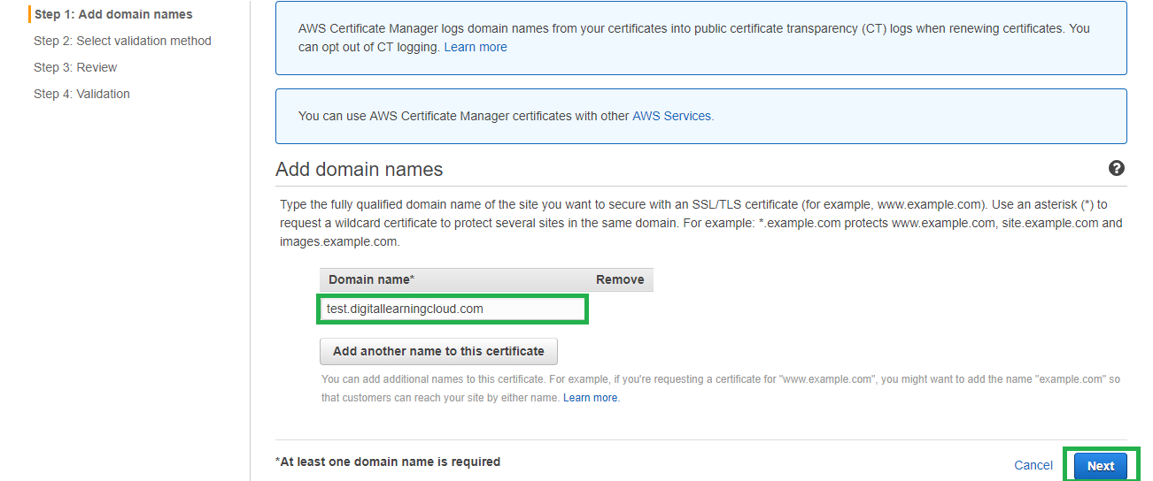

1. Select the validation method for this request. Easy way is to go with Email validation as DNS validation requires adding records to your domain.

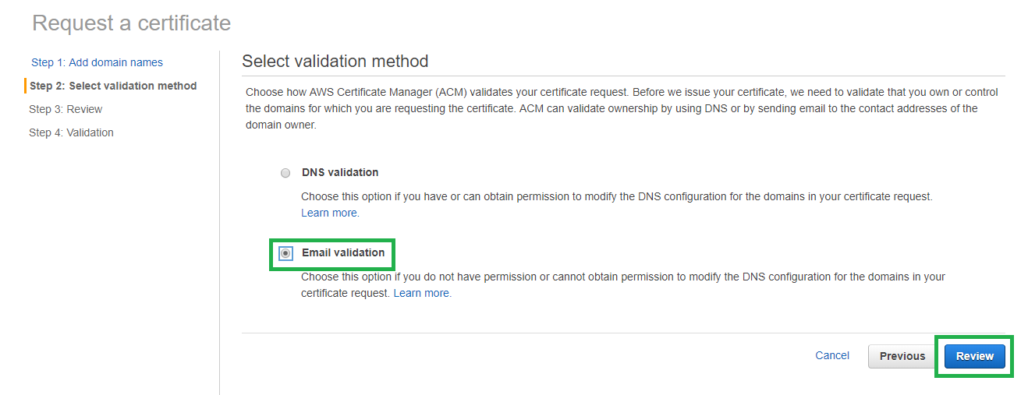

1. Click confirm and request.

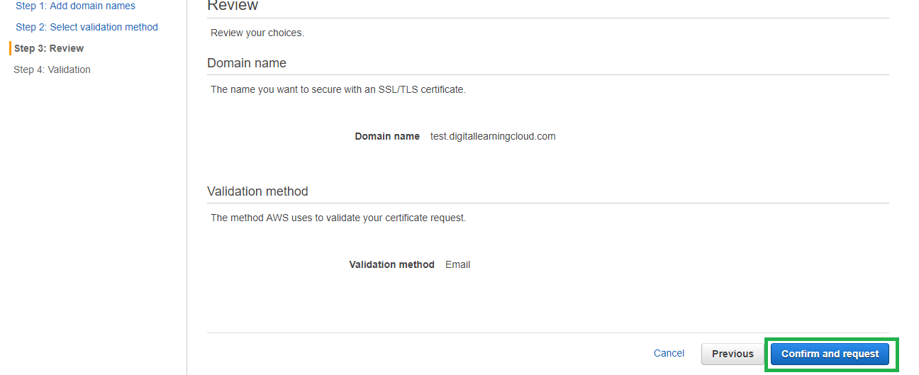

1. Request in progress is displayed as validation is pending. Click continue.

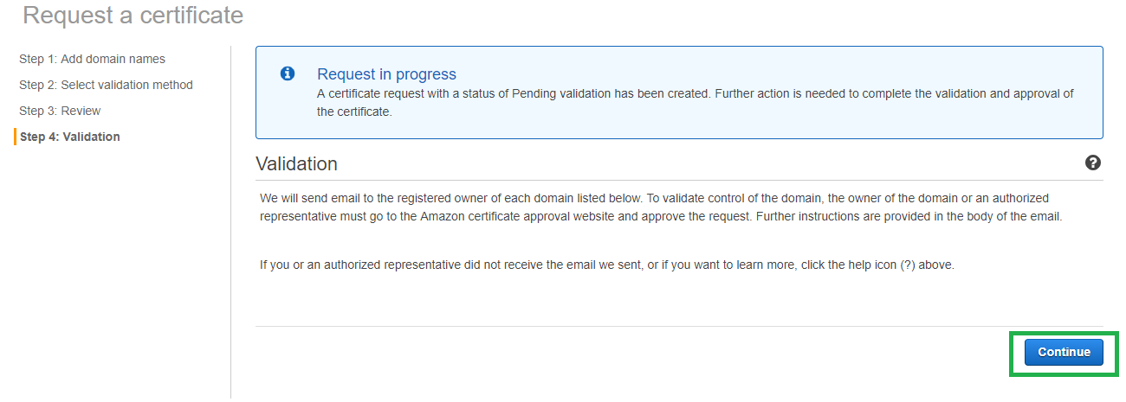

1. Current status is pending verification as you have to approve the email for the validation.

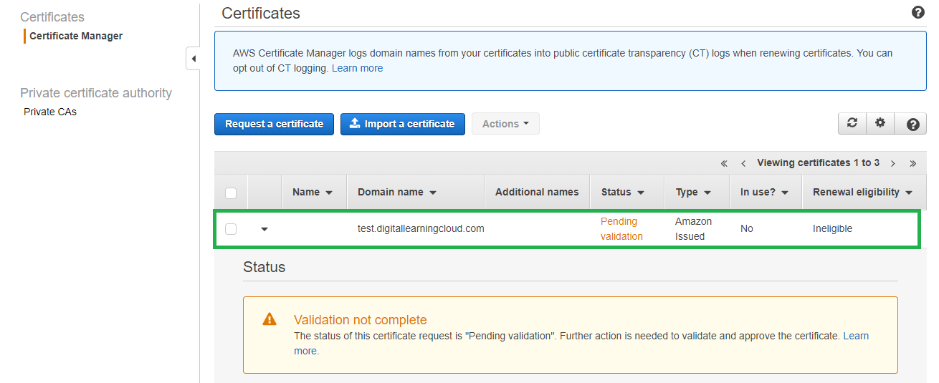

1. Open the Email received from amazon for validating and approving the request.

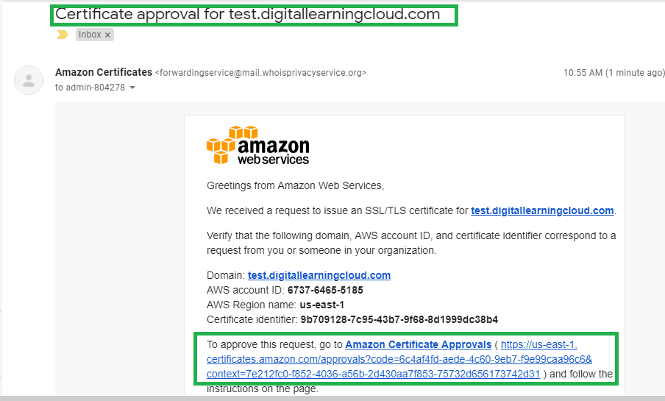

1. Click the approve link and approve it.

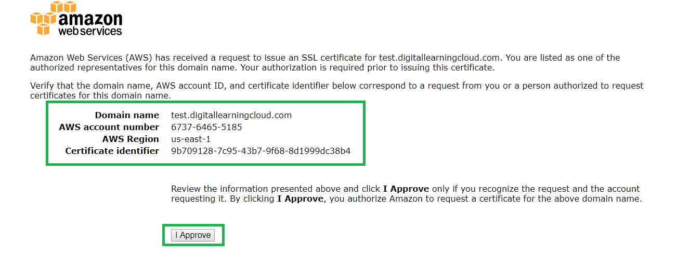

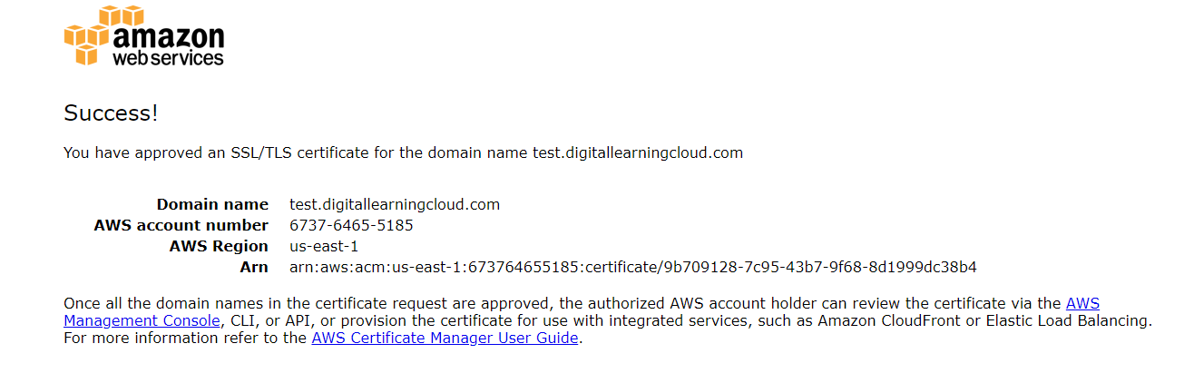

1. As the validation is completed the certificate status changed to issued and ready for use.

